1. INTRODUCTION
1.1 Introduction to Project
Alumni connectivity plays a crucial role in maintaining a strong relationship between graduates and their alma mater. Over the years, alumni associations have evolved from simple networking groups to dynamic platforms that offer professional growth, mentorship, and philanthropic opportunities.
The proposed project, LinkUp, aims to develop a web-based Alumni Association Platform that fosters connectivity, professional networking, and community engagement. The platform will serve as a central hub where alumni can register, network, seek job opportunities, and contribute to the institution’s initiatives. Additionally, the platform introduces SmartNest, a collaborative space where alumni can interact with students on projects, internships, and discussions. An AI chatbot will assist users by providing information, answering queries, and improving the overall user experience. This initiative will strengthen alumni-institution relationships, encourage contributions, and support both alumni and students in their career and academic pursuits.
1.2 Project Category
The LinkUp project falls under the category of Web-Based Alumni Management System. It is a networking and engagement platform that integrates functionalities such as alumni registration, job postings, professional networking, mentorship, event management, and donation processing. Additionally, it includes a collaborative learning system (SmartNest) powered by AI, enhancing communication between alumni and students.
1.3 Objectives
The key objectives of this project are:
- Enhancing Alumni Engagement: Providing a structured platform to maintain active connections between alumni and the institution.
- Facilitating Professional Networking: Enabling alumni to connect based on industries, expertise, and geographical locations.
- Supporting Career Advancement: Offering job listings, internship opportunities, and mentorship programs for students and alumni.
- Encouraging Philanthropy: Providing a secure donation portal to support college initiatives.
- Promoting Student-Alumni Collaboration: Establishing SmartNest, a space where students and alumni can collaborate on projects and share knowledge.
- Implementing AI Assistance: Integrating an AI chatbot to provide instant guidance, resolve queries, and improve user experience.
1.4 Problem Statement
Traditional alumni association systems face several challenges, including lack of engagement, inefficient communication, and limited career support. Many alumni lose touch with their institution due to the absence of an interactive, user-friendly platform. Existing systems often fail to provide professional networking tools, job opportunities, and meaningful collaboration between alumni and students.
Key problems in traditional alumni management systems:
- Lack of structured networking opportunities.
- Limited access to career growth resources.
- Absence of a centralized job portal.
- Difficulty in facilitating alumni donations and institutional contributions.
- No interactive platform for alumni-student collaborations.
- Poor engagement due to outdated communication methods.
LinkUp addresses these challenges by offering a comprehensive digital platform with networking tools, career resources, a donation portal, and SmartNest for collaborative learning.
1.5 Existing System and Its Demerits
Existing System:
Most institutions rely on traditional alumni engagement methods such as:
- Social media groups (LinkedIn, Facebook, WhatsApp).
- Alumni meet-ups and reunions.
- Basic alumni web portals with limited functionalities.
- Manual communication via email/newsletters.
Demerits:
- Lack of Centralization: Information is scattered across multiple platforms, making it difficult for alumni to stay connected.
- Inefficient Networking: No proper system to connect alumni based on shared interests or industries.
- Limited Career Support: No structured job portal for alumni to seek or post job opportunities.
- No Real-Time Assistance: Existing systems lack an AI chatbot for immediate query resolution.
- Manual and Time-Consuming: Communication relies heavily on emails and newsletters, leading to delayed responses.
- No Student-Alumni Collaboration: Lack of a structured system for mentorship, internships, and collaborative projects.
1.6 Proposed System and Its Merits
Proposed System:
LinkUp is a fully integrated alumni management system designed to overcome the shortcomings of traditional alumni networks. It will provide a seamless and interactive web-based platform with the following features:
- Alumni Registration: Easy sign-up process for alumni with profile management.
- Networking Hub: Advanced search and filtering options to connect alumni based on location, industry, and interests.
- Job Portal: Alumni can post and apply for jobs within the community.
- Donation Portal: Secure online donation system for alumni contributions.
- SmartNest: A collaborative platform for alumni and students to engage in projects, discussions, and internships.
- AI Chatbot: Provides instant responses to queries, assisting users in navigation and career-related inquiries.
- Event Management: Alumni can register for and organize events, reunions, and webinars.
- Feedback and Surveys: Allows alumni to provide suggestions for platform improvement.
Merits of the Proposed System:
- Enhanced Alumni Engagement: The platform strengthens alumni-institution relationships with structured communication and engagement tools.
- Centralized Networking: Alumni can connect based on industries, expertise, and interests in one unified platform.
- Career Growth Opportunities: The job portal facilitates employment and mentorship opportunities.
- Efficient and Secure Donations: The donation portal ensures easy and secure contributions.
- AI-Powered Assistance: The chatbot improves user experience with quick responses and guidance.
- Student-Alumni Collaboration: SmartNest enables knowledge sharing, project collaboration, and internship opportunities.
- Scalability and Security: Built using modern technologies (React, Django, PostgreSQL) with SSL/TLS encryption and JWT authentication.
- User-Friendly Interface: Designed with responsive UI/UX to support seamless navigation across all devices.
2. REQUIREMENT ANALYSIS AND SYSTEM SPECIFICATION
2.1 Feasibility Study
A feasibility study is crucial to assess whether the LinkUp platform is viable in terms of economics, technology, and operations. Below is an analysis of different feasibility aspects:
2.1.1 Economic Study
The development of LinkUp requires an initial investment in technology, infrastructure, and skilled personnel. Key cost components include:
- Development Costs: Costs associated with front-end and back-end development, including React.js, Django, and PostgreSQL implementation.
- Hosting and Maintenance: Expenses for cloud hosting, database storage, security, and ongoing maintenance.
- AI Integration: Costs related to implementing the AI chatbot in SmartNest for user interaction and learning support.
- Marketing and Outreach: Promotional activities to encourage alumni participation.
Despite these costs, the platform is expected to provide high returns by enhancing alumni engagement, increasing donations, and providing career opportunities for students and alumni. Additionally, monetization strategies such as premium job postings or featured alumni stories can generate revenue.
2.1.2 Technical Study
The technical feasibility evaluates whether the required technology stack and infrastructure can support the LinkUp platform effectively. Key technical considerations include:
- Frontend: React.js for an interactive and responsive user interface.
- Backend: Django and Django Rest Framework (DRF) for handling authentication, alumni data management, and interactions.
- Database: PostgreSQL for storing user data, event details, and job postings securely.
- Authentication: JWT for secure login and access control.
- AI Integration: Natural language processing (NLP) model to power the chatbot in SmartNest.
- Containerization: Docker for smooth deployment and scalability.
- Security: SSL/TLS encryption, Django security middleware, and secure database management.
These technologies are widely used, scalable, and maintainable, making the project technically feasible.
2.1.3 Operational Study
Operational feasibility assesses how well LinkUp will function in real-world conditions and whether it meets user needs effectively.
- User Experience: The platform will be designed with an intuitive UI/UX, ensuring ease of use for all alumni, including non-technical users.
- Scalability: The system will handle large numbers of users, including alumni, students, and administrators.
- Security and Privacy: User data will be protected using encryption and access control measures.
- Support and Maintenance: Continuous monitoring, bug fixes, and feature enhancements will be implemented based on user feedback.
- Collaboration Features: SmartNest will facilitate real-time discussions, project collaboration, and mentorship opportunities, improving engagement.
The system will seamlessly integrate alumni interactions, job postings, donations, and event management, ensuring successful operational deployment.

2.2 SDLC Model
To ensure efficient development, LinkUp will follow the Agile Software Development Life Cycle (SDLC) model. Agile allows for continuous iterations, enabling quick adjustments based on feedback.
Phases of Agile SDLC:
- Requirement Gathering: Identify features such as alumni networking, job postings, and SmartNest.
- Planning: Define sprint cycles for modular development (e.g., separate sprints for registration, AI chatbot, job portal).
- Design: Create UI/UX wireframes and database schema.
- Development: Implement backend APIs, frontend interfaces, and AI chatbot functionalities in iterations.
- Testing: Conduct unit testing, integration testing, and user acceptance testing.
- Deployment: Launch the platform on a cloud server using Docker for containerized deployment.
- Maintenance & Updates: Regular updates based on user feedback and technological advancements.
The Agile model ensures flexibility, faster releases, and continuous improvement, making it suitable for LinkUp.

2.3 Software Description
LinkUp is a web-based alumni networking and collaboration platform. It integrates multiple functionalities, including:
- Alumni Registration: A streamlined process allowing alumni to create accounts and update profiles.
- Networking Hub: Alumni can connect with each other based on industry, interests, or location.
- Job Portal: Alumni can post and apply for jobs, facilitating career growth.
- Donation Portal: Secure payment gateway for alumni to contribute financially.
- Event Management: Alumni can register for reunions, webinars, and networking events.
- SmartNest: A collaboration space for alumni and students to engage in projects, discussions, and mentorship.
- AI Chatbot: Provides instant support by answering user queries and guiding them through the platform.
Technology Stack:
- Frontend: React.js + Tailwind CSS for a responsive UI.
- Backend: Django with Django Rest Framework (DRF) for handling API requests.
- Database: PostgreSQL for structured data storage.
- Authentication: JWT-based secure authentication.
- AI Chatbot: NLP-based assistant for user interaction.
- Deployment: Docker containers for scalable deployment.
The LinkUp platform aims to provide an efficient, secure, and user-friendly experience for alumni engagement.

2.4 Hardware Description
To host and maintain LinkUp, the following hardware resources will be required:
Server-Side Requirements:
- Cloud Server (AWS, DigitalOcean, or Azure)
  - Processor: 4+ Core CPU (Intel Xeon / AMD EPYC)
  - RAM: 16GB+ (to handle multiple requests)
  - Storage: SSD-based 100GB+ (to store alumni data and media files)
  - Bandwidth: High-speed connection to support concurrent users
Client-Side Requirements:
- Device Compatibility:
  - PC/Laptops: Windows, macOS, Linux (latest versions)
  - Mobile Devices: Android & iOS compatibility
- Browser Support:
  - Google Chrome, Mozilla Firefox, Microsoft Edge, Safari

Development Environment:
- Development Machines:
  - Processor: Intel i5 or higher
  - RAM: 8GB+
  - Storage: SSD 256GB+
- Required Tools:
  - VS Code / PyCharm (for development)
  - Postman (for API testing)
  - Docker (for containerized deployment)
These hardware specifications ensure the system operates efficiently, providing a seamless experience for alumni, students, and administrators.

3. DESIGN
A comprehensive breakdown of the LinkUp platform’s system design, covering system analysis, architecture, workflows, module descriptions, and data flow representations.

3.1 System Analysis
Overview
System analysis involves examining the key functional and non-functional requirements of LinkUp to ensure a well-structured and efficient system. This phase helps in identifying potential system interactions, user requirements, and dependencies that influence the system’s performance and usability.
User Requirements
The system will cater to the following primary user groups:
- Alumni
  - Register and create/update their profiles.
  - Connect with other alumni based on shared interests, industry, and location.
  - Post and apply for job opportunities through the job portal.
  - Donate through the secure donation portal.
  - Participate in events, webinars, and networking meetups.
  - Share success stories and professional achievements.
  - Engage with students via SmartNest for mentorship and project collaboration.
- Students
  - Register and create/update their profiles.
  - View and apply for job opportunities posted by alumni.
  - Participate in discussions and projects in SmartNest.
  - Connect with alumni for mentorship and career guidance.
  - Receive notifications about alumni events and learning resources.
- Administrators
  - Manage alumni and student accounts.
  - Oversee and moderate networking interactions.
  - Approve and organize events.
  - Manage and validate donation transactions.
  - Track alumni achievements and success stories.
  - Oversee and improve the AI chatbot's responses.
Functional Requirements
- User Authentication: Secure login and registration using JWT-based authentication.
- Profile Management: Users can update their personal and professional details.
- Networking Hub: Alumni can search and connect with peers based on industry, location, and shared interests.
- Job Portal: Alumni can post jobs and students/alumni can apply for openings.
- Event Management: Alumni and students can view and register for upcoming reunions and career events.
- Donation Portal: Secure online donations with transaction tracking.
- Success Stories: Alumni can showcase their achievements and career growth.
- SmartNest: A collaboration space for alumni-student interaction, project discussions, and internships.
- AI Chatbot: Assists users with queries, learning recommendations, and navigation.
- Feedback and Surveys: Users can submit feedback to improve platform features.
Non-Functional Requirements
- Security: Encrypted data storage, SSL/TLS protection, and authentication security.
- Scalability: Ability to support an increasing number of users over time.
- Performance: Fast and optimized database queries to ensure smooth user experience.
- Reliability: System should be available 24/7 with minimal downtime.
- Usability: Intuitive UI/UX to ensure easy navigation for all users.

3.2 System Architecture
The LinkUp platform follows a three-tier architecture, ensuring scalability, modularity, and security.
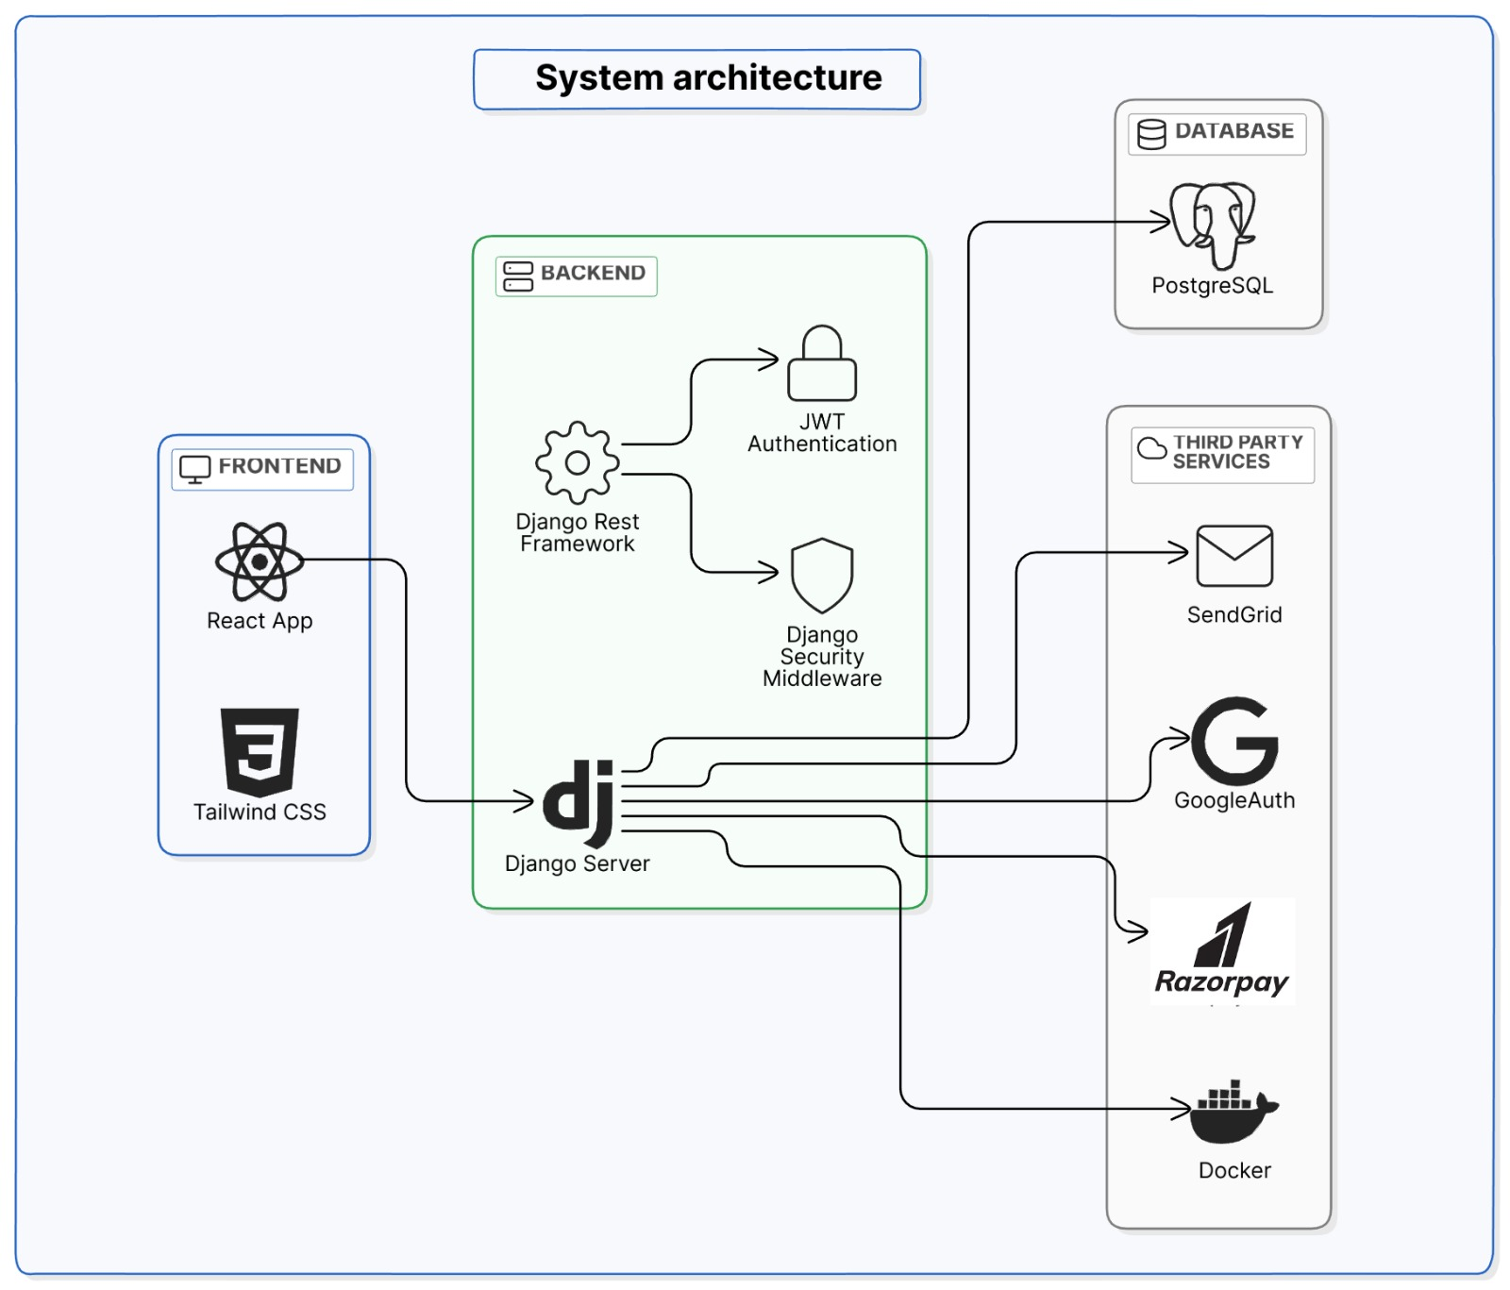
1. Presentation Layer (Frontend)
- Developed using React.js for a dynamic and responsive interface.
- Tailwind CSS / Material-UI for consistent styling.
- JWT-based authentication to manage user sessions.
- Fetches data via API calls from the backend.
2. Business Logic Layer (Backend)
- Django framework with Django Rest Framework (DRF) for handling API requests.
- Processes authentication, alumni registration, job postings, donations, and SmartNest interactions.
- Implements AI chatbot logic for SmartNest.
- Ensures data security with Django security middleware.
3. Data Layer (Database)
- PostgreSQL database to store alumni records, job postings, events, and donation history.
- Maintains structured relationships among different entities.
- Uses Django ORM for efficient database interactions.
Supporting Technologies
- Docker: Ensures containerized deployment.
- SendGrid: Manages email notifications.
- NLP Model: Powers the AI chatbot.
- Cloud Hosting (AWS, DigitalOcean, or Azure): For scalable and secure hosting.

3.3 Work Flow Diagram
The following workflow outlines how users interact with LinkUp:
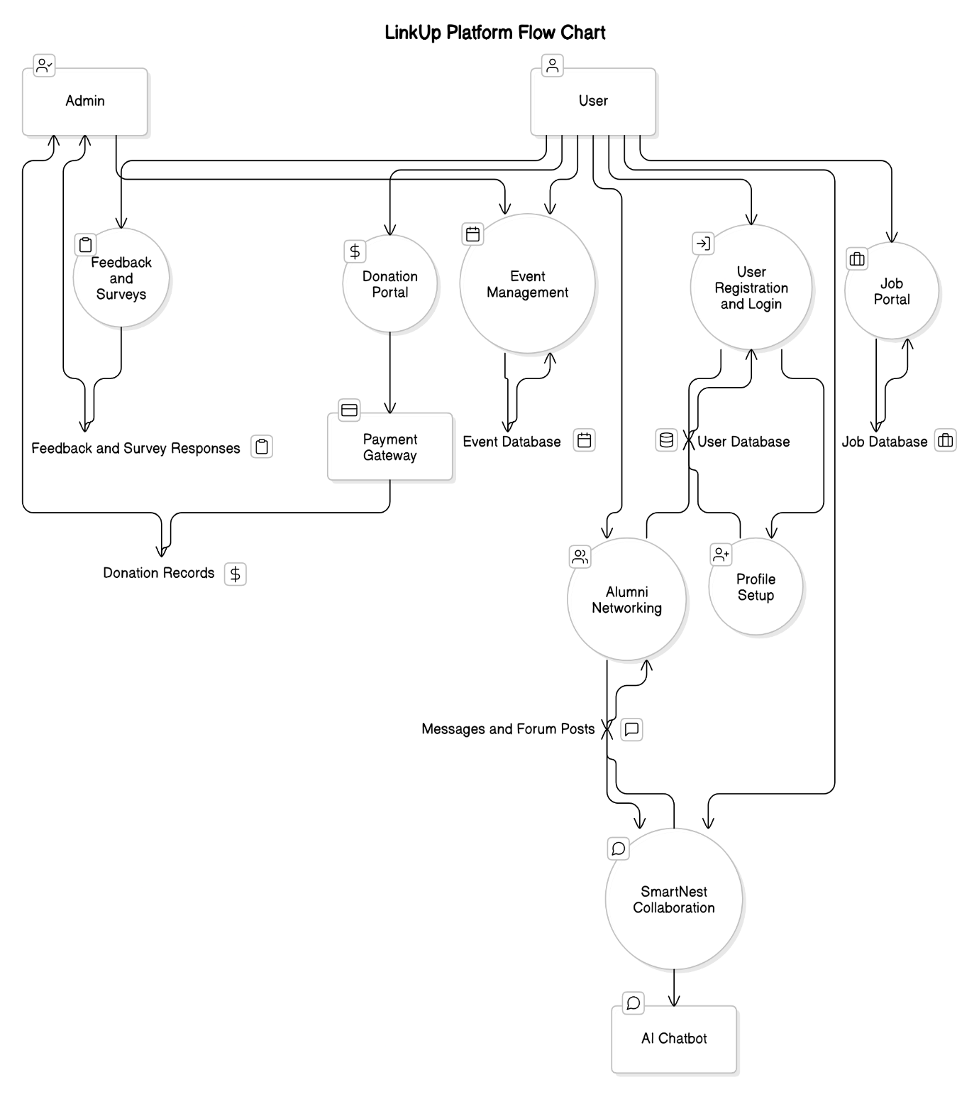
- User Registration & Login
  - Users sign up or log in using email authentication.
  - JWT authentication validates user sessions.
- Profile Setup
  - Users update their personal, academic, and professional details.
- Alumni Networking
  - Users search for alumni based on location, industry, or interests.
  - Connect via private messaging or public discussion forums.
- Job Portal
  - Alumni post job openings.
  - Students/alumni browse jobs and apply.
- Event Management
  - Admins create events.
  - Alumni and students register for events.
- Donation Portal
  - Alumni contribute securely through an integrated payment system.
  - Admins track donation records.
- SmartNest Collaboration
  - Students and alumni engage in project discussions.
  - AI chatbot assists with queries.
- Feedback & Surveys
  - Users submit feedback for platform improvements.

3.4 Module with Description
The system consists of the following core modules:
Module | Description
User Management | Handles user authentication, profile setup, and access control.
Alumni Networking | Enables alumni to connect based on industry and interests.
Job Portal | Facilitates job postings and applications.
Event Management | Organizes and tracks alumni-related events.
Donation System | Securely processes and tracks alumni donations.
Success Stories | Allows alumni to showcase their career progress.
SmartNest | Provides project collaboration and mentorship space for alumni-student interaction.
AI Chatbot | Assists users with queries and navigation.
Feedback System | Collects user feedback to improve platform functionality.

3.5 Data Flow Diagram (Level 0,1)
Level 0 Data Flow Diagram (DFD) – Context Diagram
The Level 0 DFD provides a high-level overview of how data flows between users and the system.
Entities:
- Alumni (External Entity)
- Students (External Entity)
- Admin (External Entity)
Processes:
- User Registration & Authentication
- Profile Management
- Alumni Networking
- Job Portal
- Event Registration
- Donation Processing
- AI Chatbot Interaction
- Feedback Collection

Data Stores:
- User Database
- Job Listings
- Event Records
- Donation Transactions
- Chatbot Data
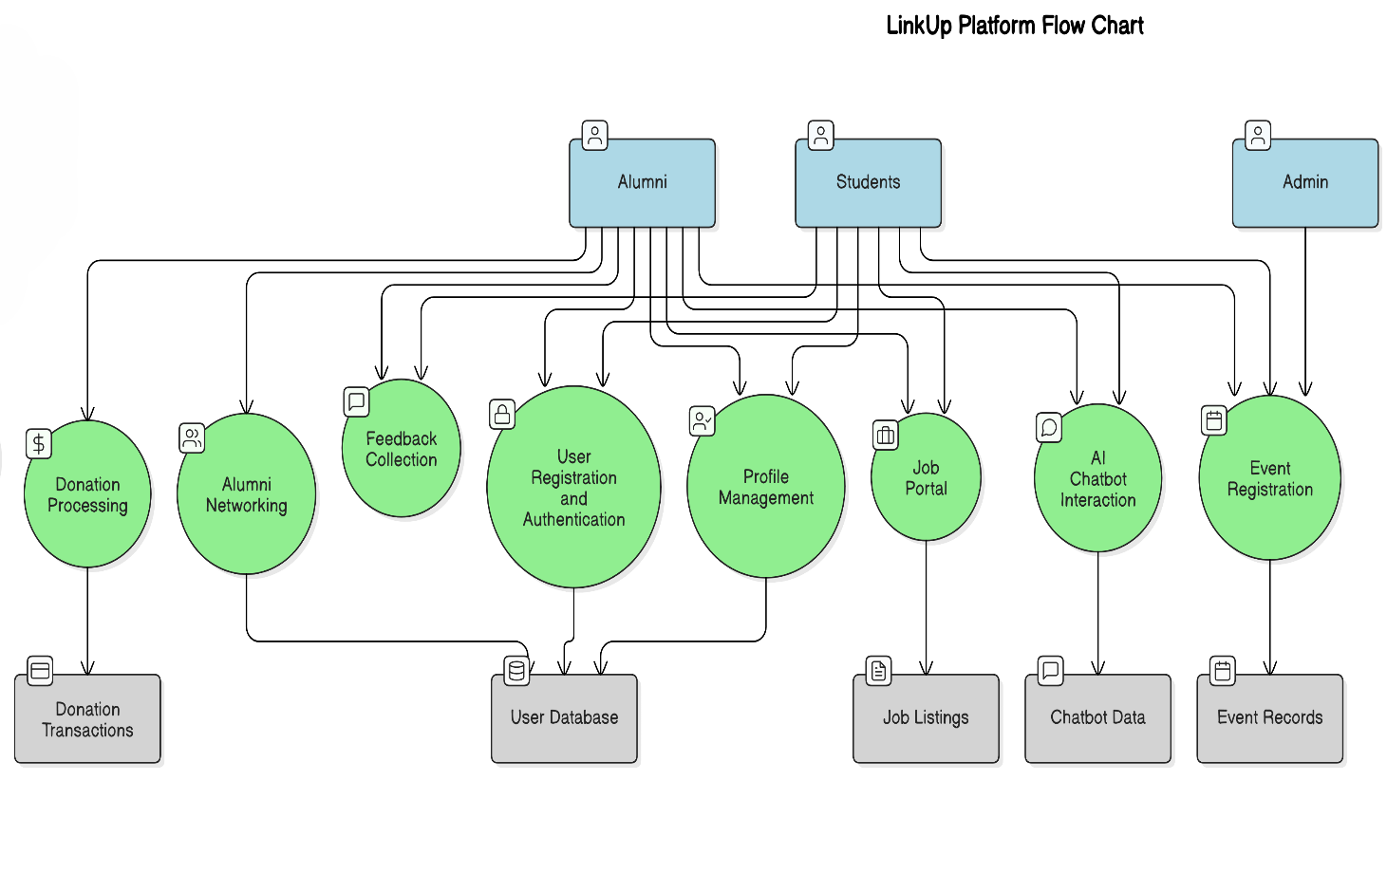

Level 1 Data Flow Diagram (DFD)
A detailed breakdown of how individual processes interact with the data stores:
- User Registration & Authentication
  - User submits credentials → JWT authentication validates access → User profile is stored.
- Profile Management
  - User updates profile → Data is saved in the user database.
- Alumni Networking
  - User searches for alumni → Query matches relevant profiles → Connection request is sent.
- Job Portal
  - Alumni posts a job → Job listing is saved in the database → Students can browse & apply.
- Event Management
  - Admin creates an event → Event details are saved → Users register.
- Donation Processing
  - Alumni submits donation → Payment is processed securely → Transaction recorded.
- SmartNest Collaboration
  - Users engage in discussions → Messages and files are stored.
- AI Chatbot
  - User interacts with chatbot → NLP model processes query → Response is returned.

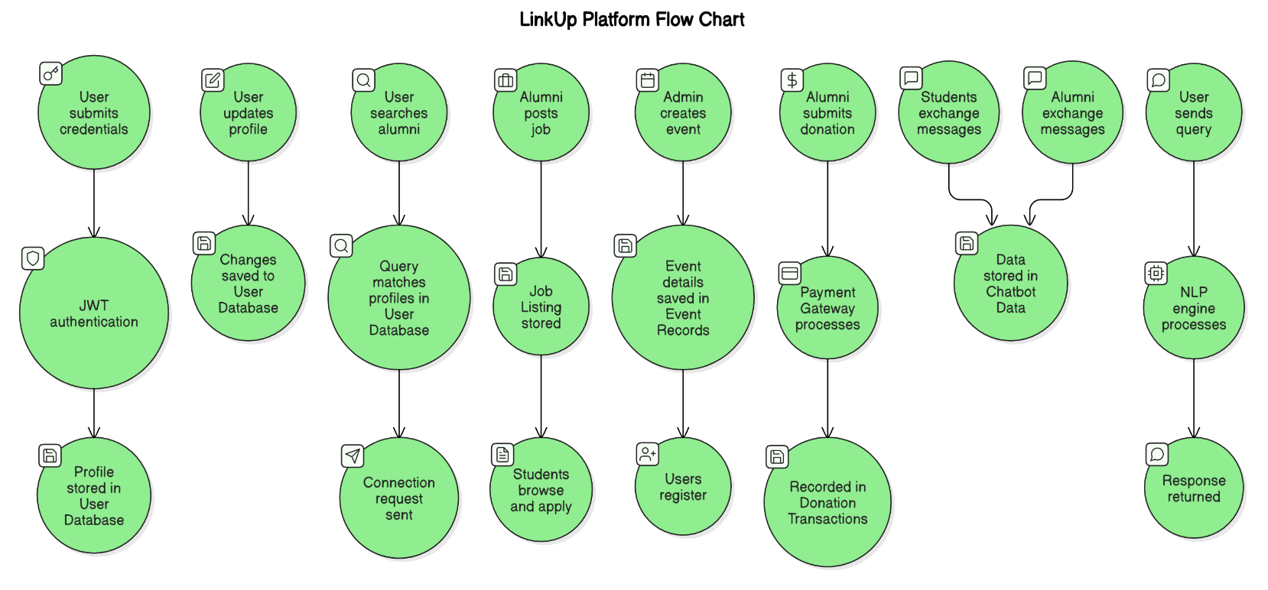

4. IMPLEMENTATION, TESTING, AND MAINTENANCE
This section details the technologies used, project scheduling, and testing procedures to ensure that LinkUp is implemented efficiently and functions as expected.

4.1 Introduction to Language and IDEs
Programming Languages & Frameworks
The LinkUp platform is built using the following technologies:
- Frontend Development
  - Language: JavaScript
  - Framework: React.js
  - Styling: Tailwind CSS / Material-UI
  - Authentication: JWT-based authentication
  - API Handling: Axios for making API requests
- Backend Development
  - Language: Python
  - Framework: Django & Django Rest Framework (DRF)
  - Database: PostgreSQL
  - Security Features: Django security middleware, SSL/TLS encryption
  - Authentication: JWT (JSON Web Token) for user authentication
- AI Chatbot Development
  - Natural Language Processing (NLP) model for chatbot functionality
  - Django-based API to handle chatbot interactions
- Deployment & DevOps
  - Containerization: Docker for ensuring a consistent development and deployment environment
  - Email Notifications: SendGrid for automated email notifications
  - Cloud Hosting: AWS / DigitalOcean / Azure

IDEs and Development Tools
To streamline development, the following IDEs and tools are used:
Tool/IDE | Purpose
Visual Studio Code (VS Code) | Main IDE for frontend and backend development
PyCharm | Secondary IDE for Python/Django development
Postman | API testing tool for backend services
Git & GitHub | Version control system for tracking code changes
Docker | Containerization to ensure consistency across environments
Figma | UI/UX design and wireframing

4.2 Project Scheduling
The implementation of LinkUp follows a structured project timeline using the Agile methodology. The project is divided into multiple sprints, ensuring continuous feedback and improvements.
Project Phases and Timelines
Phase | Task Description | Duration
Sprint 1 | Requirements gathering, feasibility analysis | 2 Weeks
Sprint 2 | UI/UX design in Figma, frontend setup | 2 Weeks
Sprint 3 | Backend setup with Django, API development | 3 Weeks
Sprint 4 | Database schema design and integration | 2 Weeks
Sprint 5 | Authentication & user management implementation | 2 Weeks
Sprint 6 | Core features: Alumni networking, job portal | 3 Weeks
Sprint 7 | SmartNest development with AI chatbot | 3 Weeks
Sprint 8 | Donation portal & event management | 2 Weeks
Sprint 9 | Testing, bug fixing, and deployment preparation | 3 Weeks
Sprint 10 | Final deployment and post-launch maintenance | Ongoing
Development Strategy
- Incremental Development: Core features are built and tested in phases.
- Parallel Development: Frontend and backend teams work simultaneously.
- User Testing: Each sprint includes testing sessions to ensure reliability.

4.3 Testing
Testing is a crucial phase to ensure the system works correctly, is secure, and provides a seamless user experience.
Types of Testing Conducted
1. Unit Testing
- Ensures individual components (functions, APIs) work as expected.
- Conducted using PyTest (for Django) and Jest (for React.js frontend).
2. Integration Testing
- Tests interactions between different system modules.
- Ensures frontend properly communicates with backend APIs.
- Tools used: Postman, Selenium.
3. Functional Testing
- Validates the main functionalities of the system:
  - User authentication
  - Profile management
  - Alumni networking
  - Job portal
  - Event registration
  - AI chatbot interactions

4. Performance Testing
- Measures system speed and scalability under high traffic.
- Conducted using JMeter.
5. Security Testing
- Ensures data security, authentication, and user authorization.
- Tested against:
  - SQL Injection
  - Cross-Site Scripting (XSS)
  - Cross-Site Request Forgery (CSRF)
6. Usability Testing
- Conducted with a group of alumni and students.
- Feedback is collected for improving UI/UX.
Test Case Examples
Test Case ID | Test Scenario | Expected Outcome | Status
TC-01 | User Login with valid credentials | Successful login | ✅ Passed
TC-02 | User Login with invalid credentials | Error message displayed | ✅ Passed
TC-03 | Alumni creates a job posting | Job is listed in job portal | ✅ Passed
TC-04 | Student applies for a job | Application is recorded | ✅ Passed
TC-05 | AI Chatbot response accuracy | Correct and relevant response given | ✅ Passed
TC-06 | Unauthorized API access attempt | Access denied | ✅ Passed

4.4 Maintenance
Post-Deployment Maintenance Plan
Once LinkUp is deployed, a maintenance strategy is implemented to ensure smooth operation and continuous improvement.
1. Bug Fixes & Enhancements
- Regular bug tracking and fixing through GitHub Issues.
- Weekly patch releases for minor fixes and security updates.
- Feature enhancements based on user feedback.
2. System Monitoring & Performance Optimization
- Server monitoring tools (New Relic, AWS CloudWatch) track uptime and performance.
- Database optimization using indexing and query tuning.
- Load balancing and caching to handle high traffic efficiently.
3. Security Updates
- Regular updates to Django security patches.
- Monitoring for vulnerabilities and applying fixes promptly.
4. User Support & Feedback Handling
- A dedicated support system for alumni and students to report issues.
- Continuous collection of feedback via surveys and AI chatbot analytics.

6. CONCLUSION
The LinkUp Alumni Association Platform has been designed and developed to bridge the gap between alumni and their alma mater, providing a centralized hub for alumni engagement, professional networking, and career development. Through a structured SDLC approach, the platform integrates modern web technologies, secure authentication mechanisms, and AI-powered interactions to deliver a seamless user experience.
The inclusion of SmartNest, an innovative space for alumni-student collaboration, enhances the educational experience by providing mentorship opportunities, project collaborations, and internship connections. The AI chatbot further simplifies user interactions, offering instant responses to queries, guiding users through various platform features, and making alumni-student engagement more interactive.
Key achievements of the project include:
- Efficient Alumni Registration & Directory for easy networking.
- Job Portal & Mentorship opportunities to foster career growth.
- Donation Portal to facilitate philanthropic contributions.
- Event Management System to organize and participate in reunions, webinars, and other activities.
- SmartNest Collaboration Hub with an AI chatbot to assist users.
- Secure Authentication & Data Protection using JWT and Django security practices.
The project follows a scalable and maintainable architecture, ensuring future enhancements can be integrated effortlessly. Continuous feedback and iterative improvements will keep the platform aligned with evolving alumni needs.
Future Scope:
- Mobile App Development for better accessibility.
- AI-based Personalized Job Recommendations for alumni.
- Blockchain-based Certificate Verification for authenticating alumni credentials.
- Enhanced Community Features such as discussion forums, live webinars, and AI-driven content recommendations.
With LinkUp, we envision a thriving alumni network that fosters lifelong relationships, knowledge exchange, and institutional growth. The platform serves as a testament to the power of technology in strengthening alumni-institution bonds, ultimately benefiting students, faculty, and graduates alike.

7. REFERENCES
The development of this project was guided by various online resources, research papers, and industry best practices. Below are some of the key references:
Books & Research Papers
- Sommerville, I. (2015). Software Engineering (10th Edition). Pearson.
- Pressman, R. S. (2019). Software Engineering: A Practitioner’s Approach (8th Edition). McGraw-Hill.
- Tanenbaum, A. S., & Bos, H. (2014). Modern Operating Systems (4th Edition). Pearson.
- Mohapatra, H. (2022). "A Framework for Alumni Relationship Management in Higher Education Institutions." International Journal of Advanced Computer Science and Applications (IJACSA).
Online Resources & Documentation
- React.js Documentation
- Django Framework Documentation
- PostgreSQL Official Guide
- Django REST Framework Guide
- JWT Authentication Best Practices
- Docker Documentation
- SendGrid Email API Guide
- Figma UI/UX Design Principles
- OpenAI NLP Models for AI Chatbots
These resources have been instrumental in the design, development, and deployment of LinkUp. Future improvements will continue to leverage emerging technologies and industry research to keep the platform up-to-date and highly effective.

